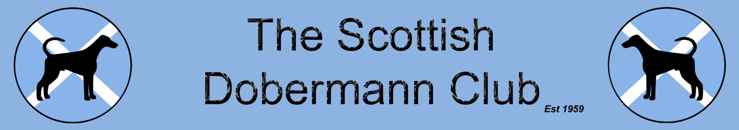

TOP POINTS WINNING SCOTTISH DOBERMANN FROM
1ST JANUARY 2019 TO 31ST DECEMBER 2019

Kennel Club name of dog………………………….......................................…..........…………….....……

Dog/ Bitch (please delete as appropriate)

Owner(s) name and address:………………………...........................................………………….....….

…………………………………………………………………............................................................…….....……

…………………………………………………………………............................................................….....………

………………………………………………………………..................................................………...............……

Telephone number………………………………….......................................………………...............…….

Allocation of Points is as shown below –

Please note Points for Dobermann breed classes and are only awarded when there are more than 2 Dobermanns present in the class. Points should be claimed for the best placings for unlimited Championship shows and 30 Open shows over the calendar year. Each applicant must have attended one SDC Show in the year applied for. Confined to Club members’ Dobermanns resident in Scotland.

CHAMPIONSHIP SHOWS
1ST-12points, 2nd-10points, 3rd-8points, 4th-6points, vhc-4points
(Limit & Open classes gain double points)

Challenge Certificate-25points, Res.CC-15points, BOB-10points
Best Puppy in Breed-10points
Group Placing–: Group 1-15pts; G2–10 pts; G3–5 pts; G4–2 pts

OPEN SHOWS
1st-4points, 2nd-3points, 3rd-2points, 4th-1point
Best of Breed-5points, BIS-10points, Res.BIS-5points
Best Puppy in Show-10points, Res.BPIS-5points

Please submit your completed claims form to the Secretary:-
Mrs Harriet McLean Bridgeholm New Trows Road Lesmahagow ML11 0JS
01555 892683 07713149585 macminpin@aol.com

No | Date | Canine Society | CH | Placing | Points  Claimed
1 |  |  | CH
2 |  |  | CH
3 |  |  | CH
4 |  |  | CH
5 |  |  | CH
6 |  |  | CH
7 |  |  | CH
8 |  |  | CH
9 |  |  | CH
10 |  |  | CH
11 |  |  | CH
12 |  |  | CH
13 |  |  | CH
14 |  |  | CH
15 |  |  | CH
16 |  |  | CH
17 |  |  | CH
18 |  |  | CH
19 |  |  | CH
20 |  |  | CH
21 |  |  | CH
22 |  |  | CH
23 |  |  | CH
24 |  |  | CH
25 |  |  | CH
26 |  |  | CH
27 |  |  | CH
28 |  |  | CH
29 |  |  | CH
30 |  |  | CH
31 |  |  | CH
32 |  |  | CH
33 |  |  | CH
34 |  |  | CH
35 |  |  | CH
36 |  |  | CH
No | Date | Canine Society | Open | Placing | Points  Claimed
1 |  |  | OPEN
2 |  |  | OPEN
3 |  |  | OPEN
4 |  |  | OPEN
5 |  |  | OPEN
6 |  |  | OPEN
7 |  |  | OPEN
8 |  |  | OPEN
9 |  |  | OPEN
10 |  |  | OPEN
11 |  |  | OPEN
12 |  |  | OPEN
13 |  |  | OPEN
14 |  |  | OPEN
15 |  |  | OPEN
16 |  |  | OPEN
17 |  |  | OPEN
18 |  |  | OPEN
19 |  |  | OPEN
20 |  |  | OPEN
21 |  |  | OPEN
22 |  |  | OPEN
23 |  |  | OPEN
24 |  |  | OPEN
25 |  |  | OPEN
26 |  |  | OPEN
27 |  |  | OPEN
28 |  |  | OPEN
29 |  |  | OPEN
30 |  |  | OPEN
 |  |  |  | TOTAL POINTS

